Objective:
  - Distinguish between hardness and hardenability.
  - Understand the concept of mass effect and ruling section.
  - Perform Jominy test as a method to indicate hardenability.

Theoretical Knowledge:
Hardenability is the ability of an alloy to be hardened by the formation of martensite as a result of a given heat treatment. It is a qualitative measure of the rate at which hardness drops off with distance into the interior of a specimen as a result of diminished martensite content.With the Jominy end-quench test, except for alloy composition, a cylindrical specimen is austenitized and upon removal from the furnace, the lower end is quenched by a jet of water. The cooling rate is a maximum at the quenched end and diminishes with position from this point along the length of the specimen. With diminishing cooling rate more time is allowed for carbon diffusion and the formation of a greater portion of the softer pearlite or bainite. A steel alloy that is highly hardenable will retain large hardness values for relatively long distances. The presence of nickel, chromium, and molybdenum in the alloy steels delay the austenite-to- pearlite and/or bainite reactions, thus permitting more martensite to form for a particular cooling rate.

Factors Affecting Hardenability:

    - Carbon Content
    - Alloying elements
    - Grain size
    - Cooling rates

TTT diagrams for (a) hypoeutectoid, (b) eutectoid and (c) hypereutectoid steels are given in Fig. 1.
As the carbon percentage increases A3 decreases, similar is the case for Ar3, i.e. austenite stabilises. So the incubation period for the austenite to pearlite increases i.e. the C curve moves to right. However after 0,8 wt%C any increase in C, Acm line goes up, i.e. austenite become less stable with respect to cementite precipitation. So transformation to pearlite becomes faster. Therefore C curve moves towards left after 0,8%C.
Almost all alloying elements (except, Al, Co) increases the stability of supercooled austenite and retard both proeutectoid and the pearlitic reaction and then shift TTT curves of start to finish to right or higher timing. This is due to i) low rate of diffusion of alloying elements in austenite as they are substitutional elements, ii) reduced rate of diffusion of carbon as carbide forming elements strongly hold them.
However Al, and Co increase rate of nucleation and growth of both ferrite or pearlite and therefore shift TTT diagram to left. In addition under the complex diffusional effect of various alloying element

the simple C shape behaviour of TTT diagram get modified and various regions of transformation get clearly separated. There are separate pearlitic C curves, ferritic and bainitic C curves and shape of each of them are distinct and different.
Fine grain size shifts S curve towards left side because it helps for nucleation of ferrite, cementite and bainite.
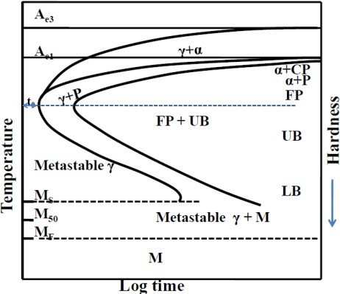
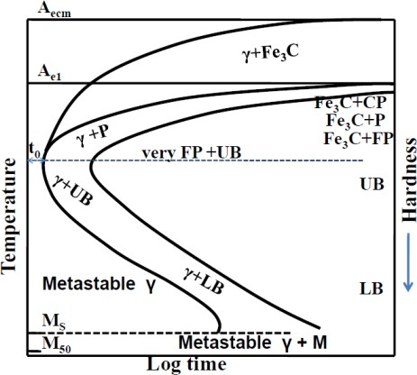
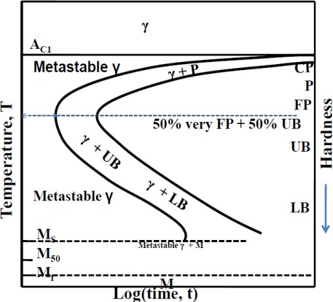

Figure 1. TTT diagrams for (a) hypoeutectoid, (b) eutectoid and (c) hypereutectoid steels

ASTM A 255 measures hardenability of steels. Hardenability is a measure of the capacity of a steel to be hardened in depth when quenched from its austenitizing temperature. Hardenability of a steel should not be confused with the hardness of a steel. The Hardness of a steel refers to its ability to resist deformation when a load is applied, whereas hardenability refers to its ability to be hardened to a particular depth under a particular set of conditions. Information gained from this test is necessary in selecting the proper combination of alloy steel and heat treatment to minimize thermal stresses and distortion when manufacturing components of various sizes.
Experimental Procedure:
First, a sample specimen cylinder either 100mm in length and 25mm in diameter, or alternatively,
101.6 mm by 25.4 mm is obtained. Second, the steel sample is austenitised. This is usually at a temperature of 800 to 900°C. Next, the specimen is rapidly transferred to the test machine (Fig. 2), where it is held vertically and sprayed with a controlled flow of water onto one end of the sample. This cools the specimen from one end, simulating the effect of quenching a larger steel component in water. Because the cooling rate decreases as one moves further from the quenched end, you can measure the effects of a wide range of cooling rates from vary rapid at the quenched end to air cooled at the far end.
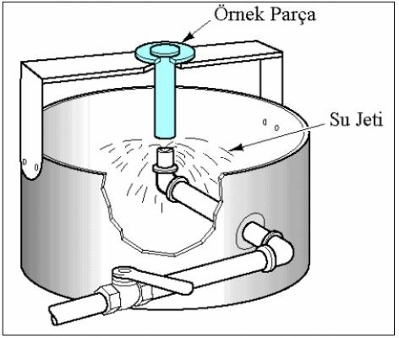

Figure 2. Schematic view of Jominy test

The hardness is measured at intervals along its length beginning at the quenched end. For alloyed steels an interval of 1.5mm is commonly used where as with carbon steels an interval of 0.75mm is typically employed.

And finally the Rockwell hardness values are plotted versus distance from the quenched end.

The Jominy Test data illustrates the effect of alloying and microstructure on the hardenability of steels. Commonly used elements that affect the hardenability of steel are carbon, boron, Chromium, Manganese, Molybdenum, Silicon, and Nickel.

Carbon is primarily a hardening agent in steel, although to a small degree it also increases hardenability by slowing the formation of pearlite and ferrite. But this affect is too small to be used as a control factor for hardenability.

Boron can be an effective alloy for improving hardenability at levels as low as .0005%. Boron is most effective in steels of 0.25% Carbon or less. Boron combines readily with both Nitrogen and Oxygen and in so doing its effect on hardenability is sacrificed. Therefore Boron must remain in solution in order to be affective. Aluminum and Titanium are commonly added as "gettering" agents to react with the Oxygen and Nitrogen in preference to the Boron.

Slowing the phase transformation of austenite to ferrite and pearlite increases the hardenability of steels. Chromium, Molybdenum, Manganese, Silicon, Nickel and Vanadium all effect the hardenability of steels in this manner. Chromium, Molybdenum and Manganese being used most often.

Requested in the Test Report
-Draw Jominy curve for 1040, 1060, 4140 and 4340 steels depending on the distance from the end.
- Explain how the Grossman hardenability test is performed and the advantages and weaknesses compared to the Jominy experiment.
- Which mechanisms reduce the hardenability of steel when Al and Co are introduced? Explain.
- Which mechanisms increase the hardenability of steel when the other alloying elements except Al and Co are introduced? Explain.
- Why is the Jominy test not applied to high alloy steels? Explain.

